Ideation Phase
Define the Problem Statements
Date | 20 January 2026
Team ID | LTVIP2026TMIDS76912
Project Name | HematoVision: Advanced Blood Cell Classification Using Transfer Learning
Maximum Marks | 4 Marks

Customer Problem Statement
Pathologists and laboratory technicians face heavy workloads, time constraints, and the risk of human error in manual blood cell analysis. Accurate classification requires expertise and is difficult to scale, especially in rural or resource-limited settings. Healthcare providers need a reliable, fast, and consistent solution that reduces manual effort while maintaining high diagnostic accuracy. HematoVision addresses this need by delivering an AI-powered blood cell classification system that enables efficient, accurate, and scalable diagnostic support.

Problem Statement 1:-
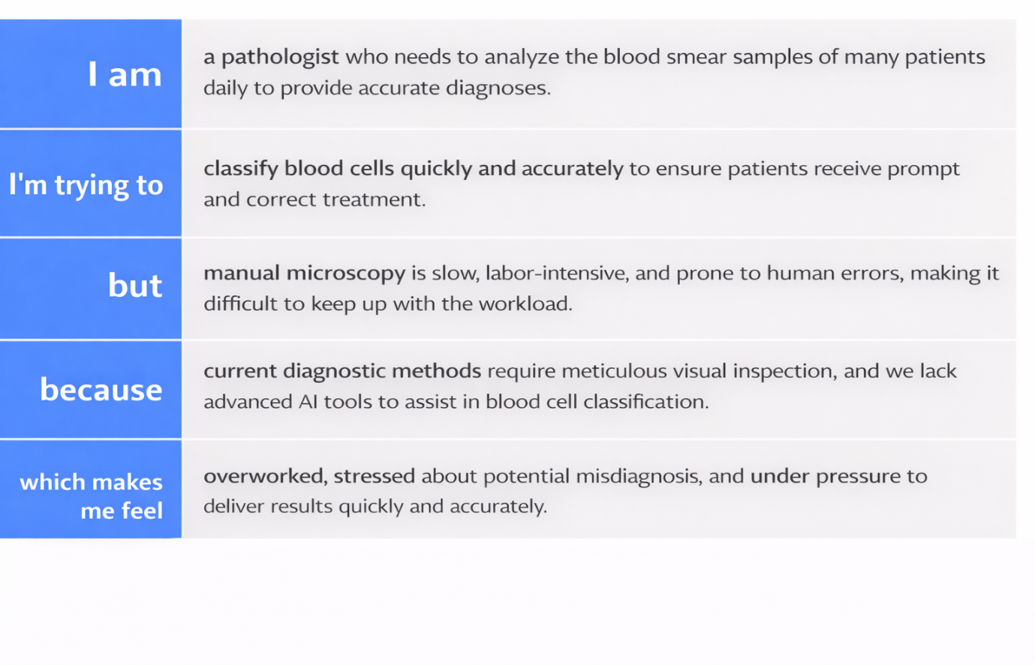

Problem Statement 2:-
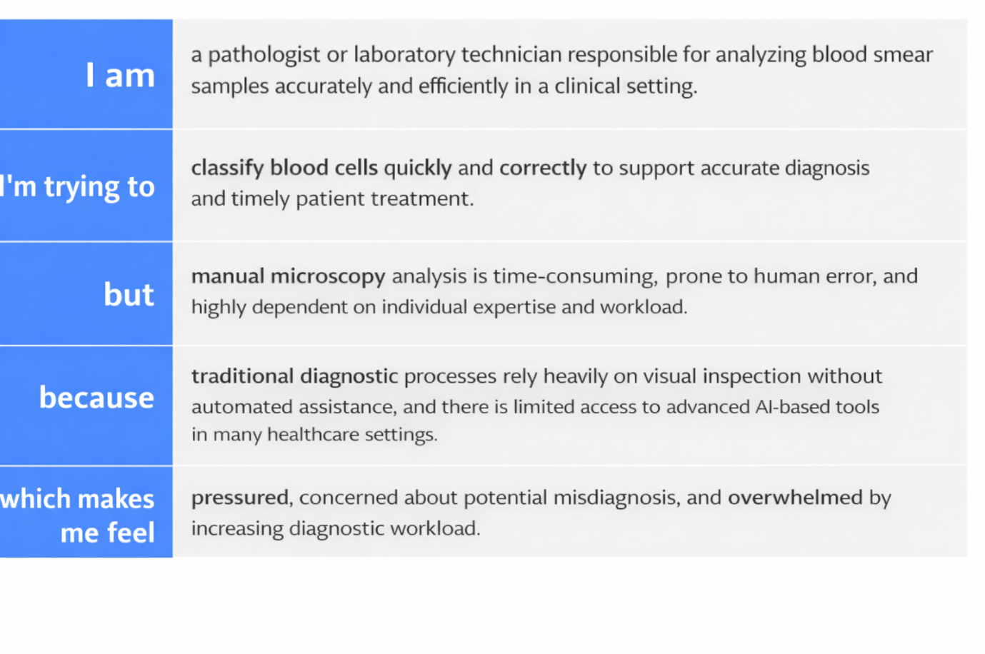
Problem Statement (PS) | I am (Customer) | I’m trying to | But | Because | Which makes me feel
PS-1 | a pathologist or laboratory technician responsible for analyzing blood smear samples accurately and efficiently in a clinical setting. | Classify blood cells quickly and accurately for diagnosis. | Manual microscopy is slow, error-prone, and depends on expertise. | Traditional diagnostics rely on manual inspection with limited AI support. | pressured, concerned about potential misdiagnosis, and overwhelmed by increasing diagnostic workload.
PS-2 | a pathologist or laboratory technician responsible for analyzing blood smear samples accurately and efficiently in a clinical setting. | Classify blood cells quickly and accurately to support timely and reliable diagnosis. | Manual microscopy is time-consuming, error-prone, and heavily dependent on individual expertise. | Traditional diagnostic methods rely mainly on visual inspection without sufficient automated AI support. | Pressured, concerned about possible misdiagnosis, and overwhelmed by increasing workload.

